Question 5 updated:
import java.util.*;
import java.io.*;
public class NewClass
{
public static void main (String[] args)
{
Scanner input = new Scanner(System.in);
ArrayList<Integer> ID = new ArrayList<>();
ArrayList<String> name = new ArrayList<>();
ArrayList<String> course= new ArrayList<>();
ArrayList<String> status = new ArrayList<>();

try
{
FileOutputStream file = new FileOutputStream("enrollment.txt");
PrintStream ps = new PrintStream(file);
for(int i =0; i<3;i++)
{
System.out.println("Enter ID of student");
int id = input.nextInt();
input.nextLine();

System.out.println("Enter name of student");
String nm = input.nextLine();
System.out.println("Enter course of student");
String cs = input.nextLine();
System.out.println("Enter enrollment status");
String st= input.nextLine();
ps.println(id + " " + nm + " " + cs +" " + st);
}
ps.close();
file.close();

}
catch(Exception e)
{
System.out.println(e.toString());
}
//read file
try
{
File file = new File("enrollment.txt");
Scanner sc = new Scanner(file);
while(sc.hasNextLine())
{
String line = sc.nextLine();
//extract id
int firstspace = line.indexOf(' ');
String id =line.substring(0,firstspace);
int iD = Integer.parseInt(id);
//extract name
int secspace = line.indexOf(' ',firstspace+1);
String nm = line.substring(firstspace+1,secspace);
//extract course
int thirdspace = line.indexOf(' ',secspace+1);
String c = line.substring(secspace+1,thirdspace);
//extract status
String s = line.substring(thirdspace+1);
ID.add(iD);
name.add(nm);
course.add(c);
status.add(s);

}
sc.close();
}
catch(Exception e)
{
System.out.println(e.toString());
}

int enroll =0;
int drop =0;
for(int i =0;i<status.size();i++)
{
if(status.get(i).equalsIgnoreCase("enrolled"))
{
enroll++;
}
else if(status.get(i).equalsIgnoreCase("Dropped"))
{
drop++;
}
}
System.out.println("Enrolled Students: " + enroll + " Dropped students: " + drop);

//Array list for programming course
for(int i =0;i<course.size();i++)
{
if(course.get(i).equalsIgnoreCase("Programming"))
{
System.out.println("Students having programming course are: ");
System.out.println(ID.get(i) + " " + name.get(i) + " " + course.get(i) + " " + status.get(i));
}
}
}
}

Question 1:
import java.util.*;
import java.io.*;
public class NewClass
{
public static void main (String[] args)
{
Scanner input = new Scanner(System.in);
try
{
FileOutputStream file = new FileOutputStream("sample.txt");
PrintStream ps = new PrintStream(file);
while(true)
{
System.out.println("Enter a line or none to exit");
String line = input.nextLine();
if(line.equalsIgnoreCase("none"))
break;
ps.println(line);
}

}
catch(Exception e)
{
System.out.println(e.toString());
}
//read data
try
{
int count = 0;
String words = "";
File file = new File("sample.txt");
Scanner sc = new Scanner(file);
while(sc.hasNextLine())
{
String str = sc.nextLine();
for(int i =0;i<str.length();i++)
{
char ch = str.charAt(i);
if(ch!=' ')
{
words+=ch;
}
else
{
count++;
words = "";
}
}
if(!words.isEmpty())
{
count++;
words = "";
}
}

System.out.println("The number words in a file is " + count);

}
catch(Exception e)
{
System.out.println(e.toString());
}
}
}
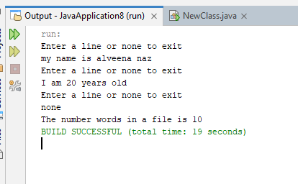

Question 2:
import java.util.*;
import java.io.*;
public class NewClass
{
public static void main (String[] args)
{
Scanner input = new Scanner(System.in);
try
{
FileOutputStream file = new FileOutputStream("books.txt");
PrintStream ps = new PrintStream(file);
while(true)
{
System.out.println("Enter a line or none to exit");
String line = input.nextLine();
if(line.equalsIgnoreCase("none"))
break;
ps.println(line);
}

}
catch(Exception e)
{
System.out.println(e.toString());
}
//read data
try
{
int count = 0;
File file = new File("books.txt");
Scanner sc = new Scanner(file);
while(sc.hasNextLine())
{
String str = sc.nextLine();
String words = "";
for(int i =0;i<str.length();i++)
{
char ch = str.charAt(i);
if(ch!=' ')
{
words+=ch;
}
else
{
if(words.equalsIgnoreCase("Java"))
{
count++;
}
words = "";
}
}
if(words.equalsIgnoreCase("Java"))
{
count++;

}

}

System.out.println("Number of occurrence of java: " + count);

}
catch(Exception e)
{
System.out.println(e.toString());
}
}
}
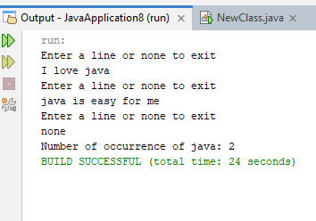

Question 3:
import java.util.*;
import java.io.*;
public class NewClass
{
public static void main (String[] args)
{
Scanner input = new Scanner(System.in);
try
{
FileOutputStream file = new FileOutputStream("numbers.txt");
PrintStream ps = new PrintStream(file);
while(true)
{
System.out.println("Enter a number or 0 to exit");
int num = input.nextInt();
if(num==0)
break;
ps.println(num);
}
ps.close();
file.close();

}
catch(Exception e)
{
System.out.println(e.toString());
}
//read data
try
{
File file = new File("numbers.txt");
Scanner sc = new Scanner(file);
System.out.println("Enter a number to find out");
int x = input.nextInt();
boolean found = false;
while(sc.hasNext())
{
int num = sc.nextInt();
if(num==x)
{
found = true;
break;
}

}
if(found)
{
System.out.println("Number found");
}
else
{
System.out.println("Not found");
}
sc.close();
}
catch(Exception e)
{
System.out.println(e.toString());
}
}
}
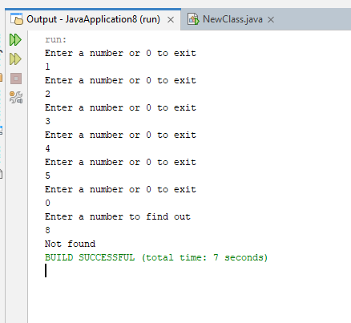
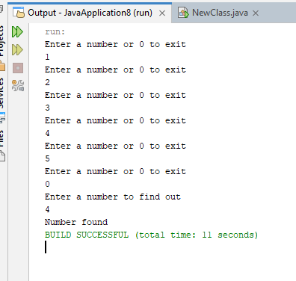

Question 4:
import java.util.*;
import java.io.*;
public class NewClass
{
public static void main (String[] args)
{
Scanner input = new Scanner(System.in);
try
{
FileOutputStream file = new FileOutputStream("attendance.txt");
PrintStream ps = new PrintStream(file);
for(int i =0; i<10;i++)
{
System.out.println("Enter Name of student");
String name = input.nextLine();
System.out.println("Enter P for present or A for absent");
String attend = input.nextLine();
ps.println(name + " " + attend);
}
ps.close();
file.close();

}
catch(Exception e)
{
System.out.println(e.toString());
}
//read data
int present =0;
int absent =0;
try
{
File file = new File("attendance.txt");
Scanner sc = new Scanner(file);
while(sc.hasNextLine())
{
String line = sc.nextLine().trim();
if(line.endsWith("P")|| line.endsWith("p"))
{
present++;
}
else if(line.endsWith("A")|| line.endsWith("a"))
{
absent++;
}

}
System.out.println("Present students: " + present + " Absent student: " + absent);
sc.close();
}
catch(Exception e)
{
System.out.println(e.toString());
}

// Another file
try
{
FileOutputStream fileSummary = new FileOutputStream("attendance_summary.txt");
PrintStream ps = new PrintStream(fileSummary);
ps.println("Attendance Summary");
ps.println("Present students: " + present);
ps.println("Absent students: " + absent);
}
catch(Exception e)
{
System.out.println(e.toString());
}
}
}
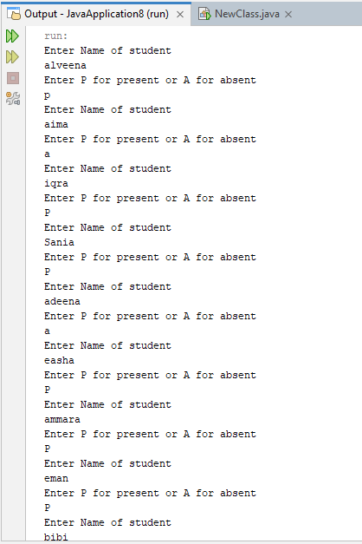
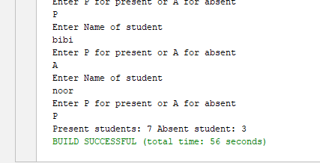
Question 5:
import java.util.*;
import java.io.*;
public class NewClass
{
public static void main (String[] args)
{
Scanner input = new Scanner(System.in);
ArrayList<Integer> ID = new ArrayList<>();
ArrayList<String> name = new ArrayList<>();
ArrayList<String> course= new ArrayList<>();
ArrayList<String> status = new ArrayList<>();

try
{
FileOutputStream file = new FileOutputStream("enrollment.txt");
PrintStream ps = new PrintStream(file);
for(int i =0; i<3;i++)
{
System.out.println("Enter ID of student");
int id = input.nextInt();
input.nextLine();

System.out.println("Enter name of student");
String nm = input.nextLine();
System.out.println("Enter course of student");
String cs = input.nextLine();
System.out.println("Enter enrollment status");
String st= input.nextLine();
ps.println(id + " " + name + " " + course +" " + status);
ID.add(id);
name.add(nm);
course.add(cs);
status.add(st);
}
ps.close();
file.close();

}
catch(Exception e)
{
System.out.println(e.toString());
}

int enroll =0;
int drop =0;
for(int i =0;i<status.size();i++)
{
if(status.get(i).equalsIgnoreCase("enrolled"))
{
enroll++;
}
else if(status.get(i).equalsIgnoreCase("Dropped"))
{
drop++;
}
}
System.out.println("Number of students enrolled: " + enroll + " Dropped: " + drop);

//Array list for programming course
for(int i =0;i<course.size();i++)
{
if(course.get(i).equalsIgnoreCase("Programming"))
{
System.out.println(ID.get(i) + " " + name.get(i) + " " + course.get(i) + " " + status.get(i));
}
}
}
}

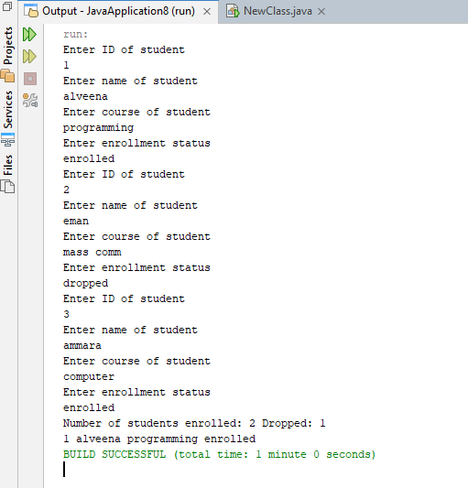

GPT QUESTION:
import java.util.*;
import java.io.*;
public class NewClass
{
public static void main (String[] args)
{
Scanner input = new Scanner(System.in);
ArrayList<Integer> roll = new ArrayList<>();
ArrayList<String> name = new ArrayList<>();
ArrayList<String> subject= new ArrayList<>();
ArrayList<Integer> marks = new ArrayList<>();

try
{
FileOutputStream file = new FileOutputStream("student.txt");
PrintStream ps = new PrintStream(file);
while(true)
{
System.out.println("Enter roll no of student or 0 to quit");
int rn = input.nextInt();
if(rn==0)
break;
input.nextLine();
System.out.println("Enter name of student");
String nm = input.nextLine();
System.out.println("Enter subject of student");
String sub = input.nextLine();
System.out.println("Enter marks of student");
int mk= input.nextInt();
ps.println(rn + " " + nm + " " + sub +" " + mk);
}
ps.close();
file.close();

}
catch(Exception e)
{
System.out.println(e.toString());
}
//read file
try
{
File file = new File("student.txt");
Scanner sc = new Scanner(file);
while(sc.hasNextLine())
{
String line = sc.nextLine();
//extract id
int firstspace = line.indexOf(' ');
String rno =line.substring(0,firstspace);
int rn = Integer.parseInt(rno);
//extract name
int secspace = line.indexOf(' ',firstspace+1);
String nm = line.substring(firstspace+1,secspace);
//extract csubject
int thirdspace = line.indexOf(' ',secspace+1);
String sub = line.substring(secspace+1,thirdspace);
//extract status
String markstr = line.substring(thirdspace+1);
int mark = Integer.parseInt(markstr);
roll.add(rn);
name.add(nm);
subject.add(sub);
marks.add(mark);
}
//find students having marks less than 60
for(int i =0;i<marks.size();i++)
{
if(marks.get(i)<60)
System.out.println("failed students: " + name.get(i));
}
//update marks
for(int i=0;i<marks.size();i++)
{
int m = marks.get(i);
if(m<60)
{
m+=10;
if(m>100)
{
m = 100;
}
}
marks.set(i, m);

}
//write new data into the file
PrintStream ps2 = new PrintStream(new FileOutputStream("student.txt"));
for(int j=0;j<roll.size();j++)
{
ps2.println(roll.get(j) + " " + name.get(j) + " " + subject.get(j) + " " + marks.get(j));
}

ps2.close();
sc.close();
}
catch(Exception e)
{
System.out.println(e.toString());
}

try
{
//Find student having physics subject with the highest marks
int max = 0;
String topperName = "";
int rn =0;
for(int k =0;k<subject.size();k++)
{
if(subject.get(k).equalsIgnoreCase("physics"))
{
if(marks.get(k)>max)
{
max = marks.get(k);
topperName = name.get(k);
rn = roll.get(k);
}
}
}
//write topper data into another file
FileOutputStream fos = new FileOutputStream("topper.txt");
PrintStream ps = new PrintStream(fos);
ps.println(rn + " " + topperName + " " + " Physics " + max );
}
catch(Exception e)
{
System.out.println(e.toString());
}

}

}

